**Digital Hearing Aid**

Submitted by

**KEMBA KRISHNA LALASA**

|  |  |  |  |  |
| --- | --- | --- | --- | --- |
| **TABLE OF CONTENTS** | | | | |
|  | | | | Page No |
| List of Tables | | |  | i |
| List of Figures | | |  | ii |
|  | | | | |
| 1. System/Software Development | | | | |
|  | **1.1** | Introduction | | 1 |
|  | **1.2** | Problem Statement | | 2 |
|  | **1.3** | Ageing | | 3 |
|  | **1.4** | Cost Gradation | | 3 |
|  |  |  | |  |
|  | | | | |
| Agile | | | | |
| **REFERENCES** | | | |  |
| **ANNEXURES** | | | |  |

**LIST OF TABLES**

|  |  |  |
| --- | --- | --- |
| **Table No** | **Table Title** | **Page No** |
|  |  |  |

**LIST OF FIGURES**

|  |  |  |
| --- | --- | --- |
| **Figure No** | **Figure Title** | **Page No** |
|  |  |  |

**INTRODUCTION**

A hearing aid is a device designed to improve hearing by making sound audible to a person with hearing loss. Hearing aids are classified as medical devices in most countries, and regulated by the respective regulations. Small audio amplifiers such as PSAPs or other plain sound reinforcing systems cannot be sold as "hearing aids". Hearing aids are used for a variety of pathologies including sensorineural hearing loss, conductive hearing loss, and single-sided deafness. Hearing aid candidacy is typically determined by a Doctor of Audiology, who will also fit the device based on the nature and degree of the hearing loss being treated.

**PROBLEM STATEMENT**

A solar powered digital hearing aid with efficient echo cancellation, noise reduction and environment adaption.

**RESEARCH**

1. **AGEING**

The first hearing aid was created in the 17th century. The movement toward modern hearing aids began with the creation of the telephone, and the first electric hearing aid was created in 1898. Some of the first hearing aids were external hearing aids. External hearing aids directed sounds in front of the ear and blocked all other noises. The apparatus would fit behind or in the ear.

* Ear Trumpet: The first firm to begin commercial production of the ear trumpet was established by Frederick C. Rein in London in 1800.
* Electronic hearing aids: The first electronic hearing aids were constructed after the invention of the telephone and microphone in the 1870s and 1880s. The first electric hearing aid, called the Akouphone, was created by Miller Reese Hutchison in 1898One of the first manufacturers of the electronically amplified hearing aid was the Siemens company in 1913.
* Vacuum Tube: The first vacuum-tube hearing aid was patented by a Naval engineer Earl Hanson in 1920. Multitone of London patented the first hearing aid to use automatic gain control. The same company introduced a wearable version in 1948.
* Transistor hearing aids: The 1952 Sonotone 1010 used a transistor stage along with vacuum tubes, to extend battery life. The first "all-transistor" hearing aids were offered in 1952, called the Microtone Transimatic and the Maico Transist-ear. In 1954, the company, Texas Instruments, produced a silicon transistor.
* Digital hearing aid: Beginning in the early 1960s, Bell Telephone Laboratories created digital processing for creating both speech and audio signals on a large mainframe computer. In the 1970s, the microprocessor was created. In 1982, at the City University of New York, a real-time full digital experimental hearing aid was created based on the digital array processor.

Very large scale integrated (VLSI) chip. "Hearing aids, signal supplying apparatus, systems for compensating hearing deficiencies, and methods" by A Maynard Engebretson, Robert E Morley, Jr. and Gerald R Popelka, filed in 1984 and issued in 1985.

The first commercial full digital hearing aid was created in 1987 by the Nicolet Corporation. Two years later, in 1989, the commercial behind-the-ear (BTE) full digital hearing aid was launched. Bell Laboratories expanded upon the hearing aid business by developing a hybrid digital-analog hearing aid. AT&T, the parent company to Bell Laboratories, pulled out of the hearing aid market and sold its rights to Resound Corporation in 1987.

The next major milestone was creating a commercial full digital hearing aid. The Oticon Company developed the first commercial full digital hearing aid in 1995. The Senso was the first commercially successful, full digital hearing aid, and was created by Widex in 1996. After the success of the Senso, Oticon began marketing their own hearing aid, the DigiFocus.

Current digital hearing aids are now programmable which enables digital hearing aids to regulate the sound on their own, without using a separate control. Recently, "Made for iPhone hearing aids" (MFi) were introduced by Resound, which enables users of MFi digital hearing aids to stream phone calls, music, and podcasts directly from iOS devices. Directly leveraging the audio processing power potential in smartphones, Jacoti BVBA from Belgium developed ListenApp, the first digital hearing aid application to win CE certification and FDA approval as a medical device.

* Hearing aid chips: DSP chips became available in 1982, and began to be implemented into hearing aids. By 1988, chips were produced in hearing aids.
* Future: Experts also say that Bluetooth technology will become a standard feature of hearing aids soon, especially since Apple has patented specific Bluetooth connectivity for hearing aids to connect to its iOS platform.

The marriage of artificial intelligence and hearing aids. Near-instantaneous translation of 27 languages and will. A new Google system might soon be able to isolate a speech signal among a plethora of other voices and background sounds. This type of A.I. would be a huge leap forward for hearing technology and allow those with hearing loss to hear someone speaking to them much more easily, no matter what the environment.

Further down the line, hearing aids might be able to connect to the world wide web without the need for a smartphone, and every manufacturer could turn the medical device into a translation machine

**Cost Gradation**

Now, prices range from 24,990 for a basic device to 2,74,990 for a premium hearing aid. which one is best for you depends on many factors like, your hearing loss, individual needs, your lifestyle, dexterity, family involvement etc.

* Basic: Entry-level hearing aids cost from 27,490 to 36,990. These hearing aids will provide the basic relief you need from hearing loss. A basic hearing aid is quite effective, especially if you spend a lot of time at home. More active people, however, will require more sophisticated hearing aids. Key features: Modern digital technology, Hardly any feedback, Multiple customizable hearing programs. Signia Orion
* Mid-range: Mid-range hearing aids cost from 52,990 to 1,29,990. Mid-range hearing aids include technological features to increase hearing comfort. Speech is automatically recognized and enhanced, and annoying background noise is eliminated. The “directional hearing” feature ensures that sound sources are localized and their position is taken into consideration in the hearing aids’ sound reproduction. Wireless connectivity with external audio sources, Speech recognition and enhancement, Effortless directional hearing. Signia Insio primax.
* Premium hearing aids cost from 1,54,990 to 2,74,990. They offer the best technology for your ears! The powerful technology in premium hearing aids picks up speech the best and reproduces conversations in crystal clear sound. Premium hearing aids can deal with even the most difficult hearing situations. Key features include: A wide range of styles and colors, Enhanced 360° spatial orientation, Automatic adjustment to various listening environments, Multi-media application if desired (for example, TV or cell phone). Signia Pure Nx

**PRODUCT DEFINITION**

A solar powered hearing aid with efficient echo cancellation and environment adaption

**SWOT ANALYSIS**

|  |  |
| --- | --- |
| **STRENGTHS**   * Solar powered * Echo cancellation * Smart apps connectivity * Language detection | **WEAKNESSES**   * Battery size * Device size * Cost * Complexity |
| **OPPORTUNITIES**   * Increasing demand * Technology adaption * Trend | **THREATS**   * Offers of competition * Market situation * Financial trends |

**REQUIREMENTS**

**High level Requirements**

* Hearing aid styles: Complete

**TASK CI**

**Make and build screenshots**



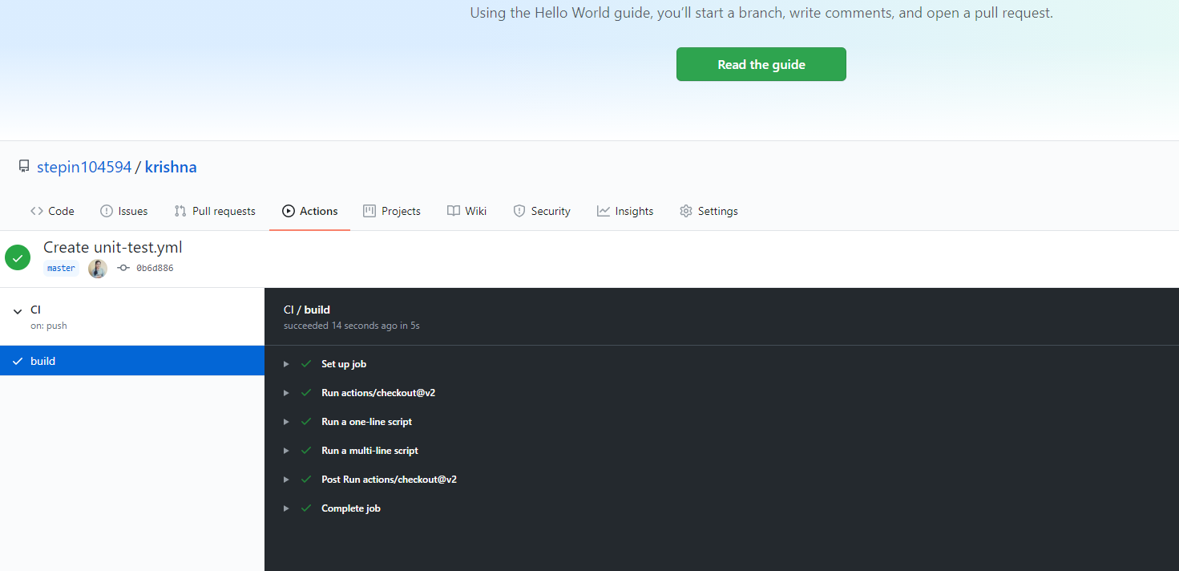

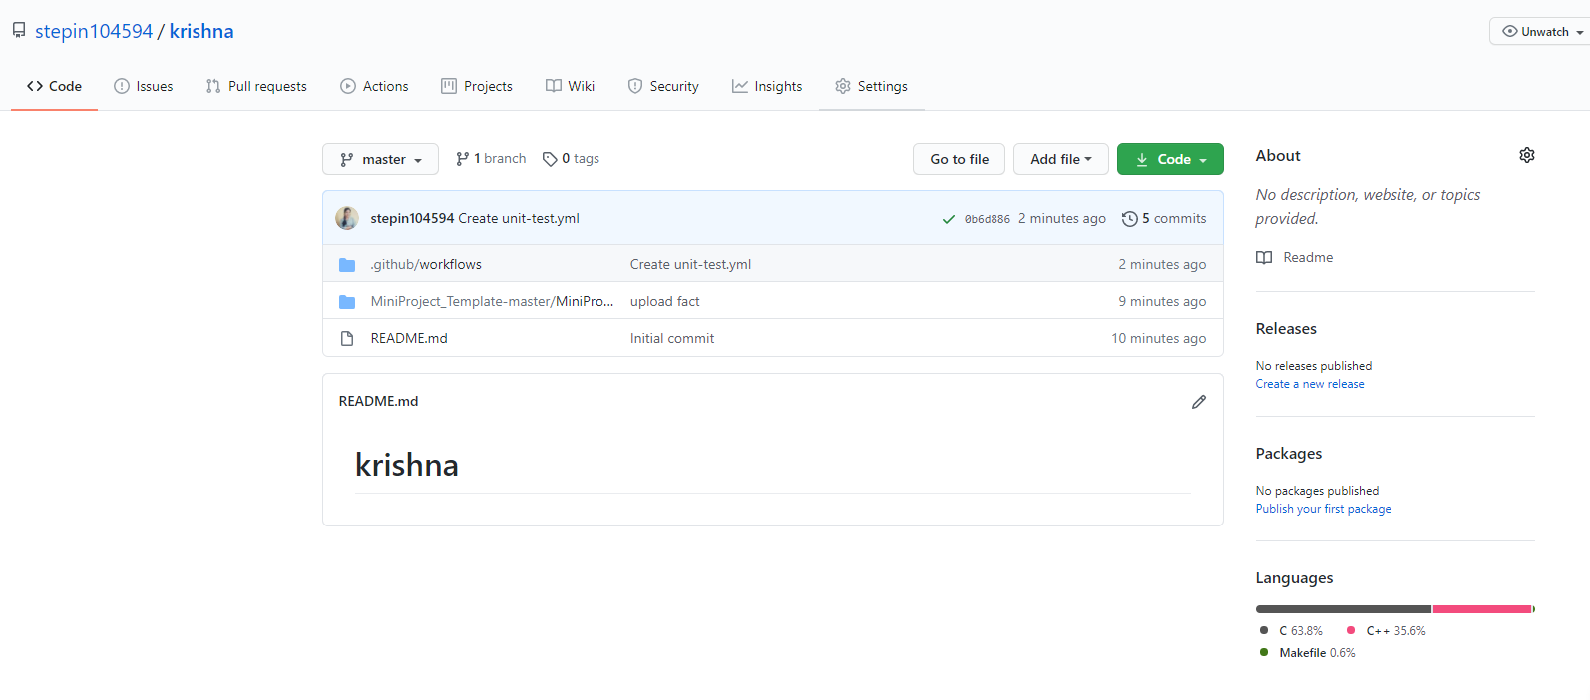

**Agile task**

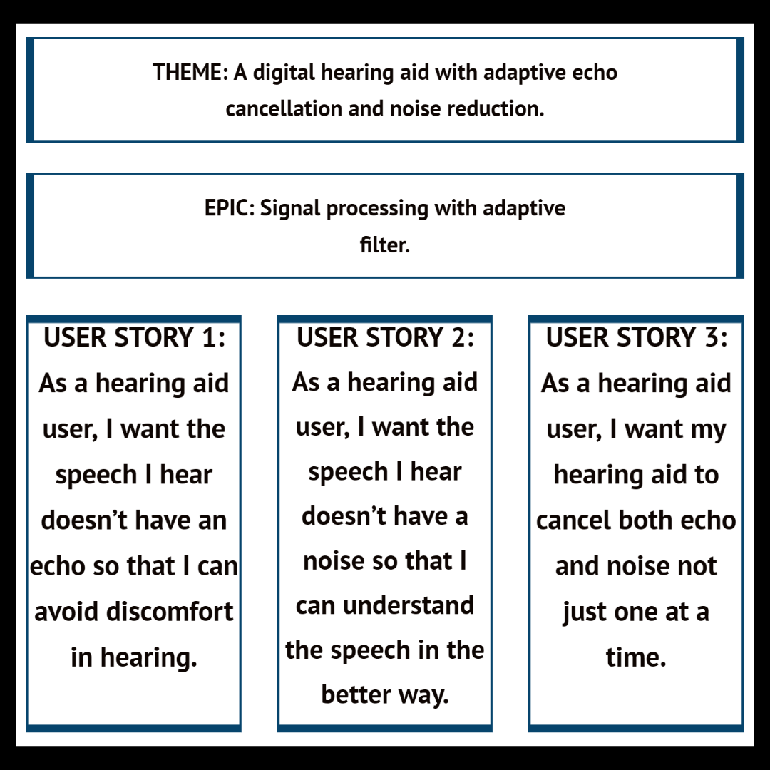

**REFERENCES**

[1] <https://en.wikipedia.org/wiki/History_of_hearing_aids>

[2] <https://www.healthyhearing.com/report/47717-Digital-hearing-aid-history>

[3] <https://en.wikipedia.org/wiki/Hearing_aid#History_of_digital_aids>

[4] <https://medicalfuturist.com/future-of-hearing/>

[5] <https://www.hear.com/in/hearing-aids/prices#:~:text=Exact%20prices%20are%20difficult%20to,for%20a%20premium%20hearing%20aid>

**ANNEXURES**